SORGHUM ROOT AND GRAIN DISEASES ASSOCIATED WITH LEGUME ROTATION SYSTEMS
Principal Researcher: Prof. N.W. McLaren
Students: Ms D. van Rooyen (PhD)
Ms L. Coetzee (PhD)
Ms P. Majopelo (MSc)
Other Collaborators: Dr G. Petersen (Texas Agrilife, Lubbock)
Dr M. Craven (ARC-Grain Crops Institute, Potchefstroom)

Root diseases of sorghum can occur at any stage from planting to plant maturity. Early infection of the primary root system results in pre-and post-emergence damping-off and seedling blight which, during the 1980's, resulted in stand losses in infected fields averaging 42%. Seedling stresses including low soil temperature and pH can predispose seedlings to a complex of soilborne pathogens. Root rot is the result of infection of the secondary root system and is often ignored because distinct above-ground symptoms are not always visible. It is only in the advanced stages of the disease that leaf scorch, due to imbalances between transpiration and water uptake, or lodging attracts attention.

Similarly to root rots, grain mold of sorghum has been associated with more than 40 genera of pathogenic fungi. The most important pathogens associated with SGM can be divided into two groups; i.e. fungi responsible for grain mold (discolouration and physical deterioration of the grain) and those that produce mycotoxins. Fungi associated with grain mold, which are regarded as the most prominent mycotoxin producers globally include Alternaria spp., Aspergillus spp., Fusarium spp., Penicillium spp. and Phoma spp. The spectrum of grain colonizers is influenced by weather and the interactions of cultivar, fungus and locality. Fusarium spp. are responsible for a majority of mycotoxins including fumonisins, moniliformin, fusaproliferin, fusaric acid, fusarins, beauvercin, gibberellic acid and T-2 toxin. Fusarium graminearum species complex produces zearalenone (ZEA) and trichothecenes, deoxynivalenol (DON), nivalenol (NIV) and derivatives.

Rotating crops is one of the key principles of conservation agriculture. A primary benefit of crop rotation remains the reduction in plant diseases, in particular diseases caused by soilborne pathogens. The principle of crop rotation lies in the reduction of available host tissues and thus, the promotion of natural mortality while complementary crop sequences can encourage beneficial allelopathy. Rotation systems with dry beans, cowpeas and soybean were compared with monoculture and fallow systems to quantify the effect on sorghum root rot, yield and grain quality at Alma commencing in 2012 ending in 2016. Trials were designed to yield a range of permutations of single legume-double sorghum and double legume-single sorghum. Visual sorghum root rot severities associated with sorghum/legume systems were significantly lower than monoculture and fallow plots although differences were relatively small ranging from an average of 27% in dry bean systems compared with 42% in sorghum monoculture systems (Figure 1). Root mass was significantly promoted by legume rotation systems, in the case of cowpea yielding masses 2.4 times those of monoculture sorghum (Figure 1). This tendency was also evident in effective root mass which is an integration of root rot and root mass ie. E= [{(100-root rot severity)/100}*root mass] indicating that stimulated root growth compensated significantly for root rot severities.
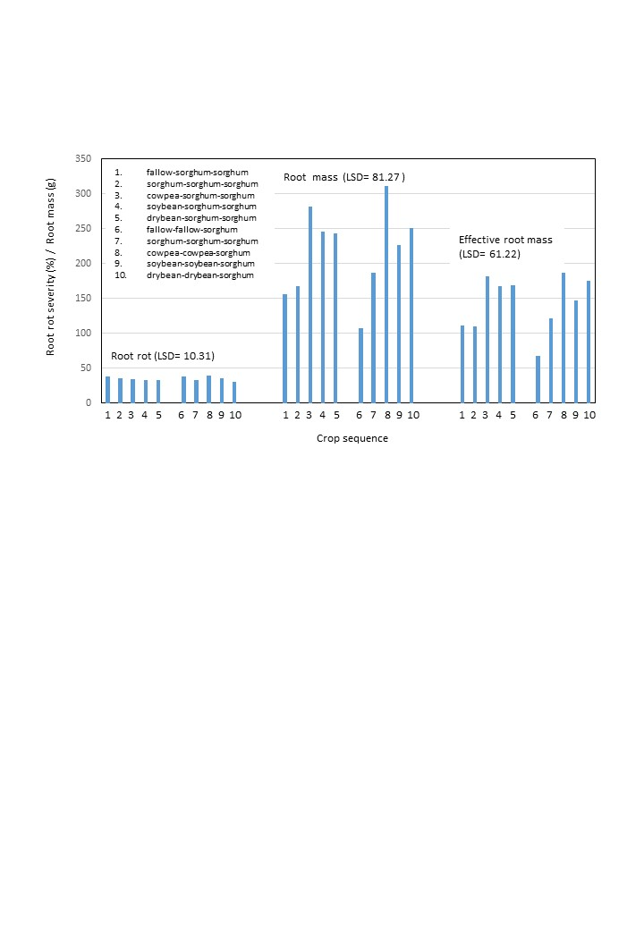
Figure 1 Root rot severity, root mass and effective root mass recorded in legume/sorghum crop rotation plots at Alma.

Double legume crops did not provide any additional benefit in terms of root rot severity, root mass and effective root mass. Mineral fertilizers may increase the tolerance of plants to disease by enabling the host to compensate for the reduced vigour of organs resulting from infection while also suppressing infection and colonization of roots by pathogenic organisms. Regression analyses indicated significant relationships between legume-associated increases in P, Na, K and Mg and effective root mass, suggesting that the increase in these elements associated with legume systems were at least partially responsible for the increases in effective root mass. Integration of the variation in the levels of K, Mg, Na and P with effective root volume in a multiple regression model yielded the following: Effective root volume = 53.38+0 .56*K+ 0.13*Mg-3.79*Na+ 4.04*P; Adjusted R²=0.87. The high R²-value highlights the importance of cropping systems that promote these elements in root development and efficiency.

Ergosterol analyses indicated significant increases in root colonization by fungi in legume rotations. Ergosterol does not distinguish between beneficial organisms and pathogens and a study has been initiated in collaboration with the ARC-Grain Crops Institute to determine which group of organisms are associated with this tendency. A highly significant positive relationship between root ergosterol content and effective root mass may suggest that legumes promote the colonization of roots by the former.

Visual grain mold ratings were higher in legume treated plots compared with monoculture and fallow treatments suggesting that legumes may harbour grain mold pathogens or result in predisposition of grains more readily than monoculture sorghum or fallow systems. F. graminearum species complex was significantly higher in legume treated plots as indicated by q-rt-PCR, in particular cowpea treated plots. These increases could also be attributed to changes in soil nutrient levels notably K and Mg as indicated by correlations between K and visual grain mold rating and ergosterol of r=0.63 and r=0.74 and Mg and visual grain mold rating and ergosterol of r=0.68 and r=0.78 respectively. Indications are that these legumes can support growth of F. graminearum and this and the increased biomass associated with these crops which could favour pathogen survival and inoculum production, may account for the increased severity of grain molds in sorghum/legume rotation systems. Mycotoxin levels in grain were relatively low which may be attributed to the warmer conditions experienced at Alma. All levels were below the maximum levels permitted by EU regulations currently applied as a guideline in local grains. Tendencies, however are for higher levels of DON and NIV which is concomitant with increased levels of colonization by FgSC.

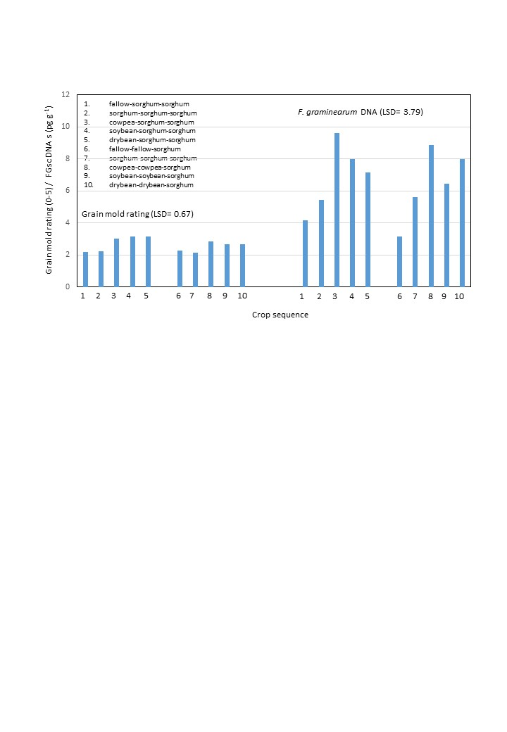

Figure 5 Grain mold ratings and F. graminearum species complex DNA levels in sorghum grain from sorghum/legume rotations systems at Alma.

Despite high grain colonization levels by grain mold pathogens, grain yields were significantly higher in sorghum/legume rotation systems. Increases in root efficiency were reflected in yield gains associated with rotation systems. It is clear that numerous studies are still required to determine the driving variables and interactions involved in these systems. Studies are on-going and have been expanded to an alternate climatic zone.

