Quantification of a leaf blight intervention threshold

Principal Researcher: Prof. N.W. McLaren
Student(s): Ms L. Coetzee (MSc-Agric)
Other Collaborators: Dr M. Craven (ARC-Grain Crops Institute, Potchefstroom)

During 2014/15 a trial was initiated at Alma to evaluate the efficacy of fungicide spray regimes applied by local commercial farmers for leaf blight (Exserohilum turcicum) control in order to optimize chemical intervention technologies, minimize unnecessary fungicide usage. Trials conducted during 2014/15 and reported on during 2015 indicated that leaf blight and anthracnose (Colletotrichum graminicola) were effectively controlled by Azoxystrobin/difenoconazole and Epoxiconazole/pyraclostrobin treatments, while treatment had a limited effect on grain mold severity.

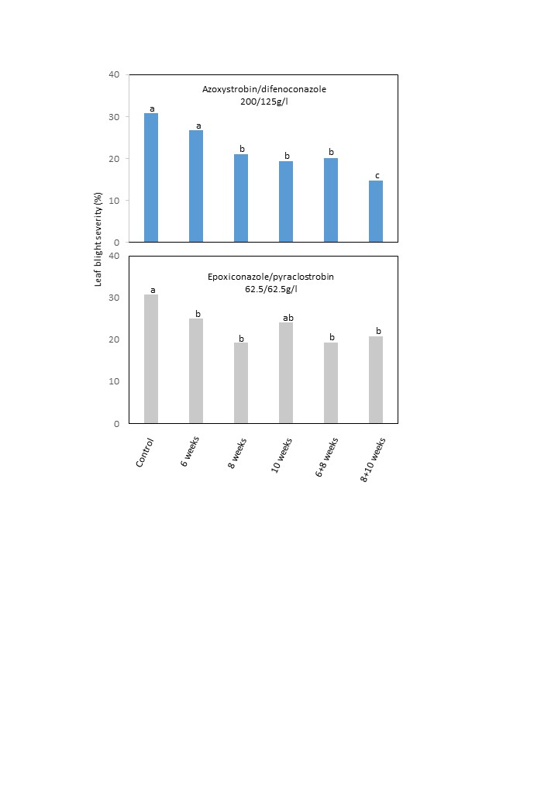

Figure 1 Effect of fungicide applications on leaf blight development at Alma during 2015/16 (mean of 5 cultivars)

The general tendency of sprays subsequent to 8 weeks after planting being more effective than earlier sprays, as recorded during 2013/14 was repeated (Figure 1) with Azoxystorbin/ Difenoconazole providing more consistent control than Epoxiconizole/Pyraclostrobin. However, trials also indicated that fixed time applications were not effective on all cultivars and a cultivar x application time interaction was evident.

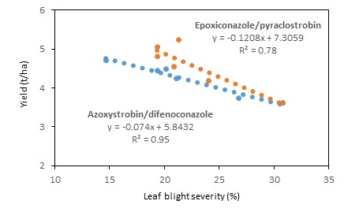

Figure 2 Relationship between yield and leaf blight severity in fungicide treated plots at Alma during 2015/16

Pooled results indicated highly significant relationships between disease severity at soft dough growth stage and yield (Figure 2). However, extrapolation of data would suggest a disease threshold level of approximately 15% before the onset of yield loss. This threshold value still requires validation, that will take place during Ms Lisa Coetzee’s Phd research during 2016/17.

Trials were also initiated to determine the optimization of intervention thresholds. Five row blocks consisting of 5 cultivars ie. PAN8816, PAN8906, NS5511, PAN8706 and PAN8625 were planted over three planting dates at Alma, Greytown and Potchefstroom during 2015/16 and leaf blight development as the estimated percentage leaf area damaged by the pathogen was monitored in relation to physiological growth stage of the host plant and yield. High temperatures and low humidity conditions limited disease development, particularly at Potchefstroom and first planting at Greytown. However, disease development rates in later plantings were an average of 34% faster than earlier plantings indicating significant weather effects on disease development. Insufficient data were available to conduct a weather x disease development rate x genotype x intervention timing analysis. Multi-location trials will be repeated during 2016/17.

