Relationship between sorghum plant and grain characteristics and colonization by the FgSC

Principal Researcher: Prof. N.W. McLaren
Students: Ms D. van Rooyen (PhD)
Other Collaborators: Dr G. Petersen (Texas Agrilife, Lubbock)

A study has been on-going to determine the relationship between plant and grain characteristics of twenty-two sorghum lines, FgSC colonisation and mycotoxin production in diverse environments. Variations in germplasm include the presence or absence of a testa, high and low phenol contents, red, tan and purple plant/glume colour and white, red and brown grain colour. The goal of the study is to determine physiological markers that may be used as a selection criterion for disease resistance since field ratings, mycotoxin levels and actual colonisation are poorly correlated.

Field trails were planted over six seasons from 2009/10 (single planting), 2010/11 (early and late planting) and 2011/12 (early and late planting) at Cedara where wetter conditions prevail and during the 2012/13 (early and late planting) and 2013/14 and 2014/15 (single plantings) in the drier Alma area. Sorghum grain mold severity was assessed in the field using a 0-5 visual rating of visible symptoms on grain and total fungal biomass was determined by ergosterol analysis subsequent to harvest. Mycotoxin levels in the samples were analysed with emphasis on DON, NIV and ZEA, toxins known to potentially occur at significant levels on sorghum grain. DNA was extracted from grains and q-rt-PCR to quantify FgSC level, was applied in the respective grain samples. Seasonal variation within the respective evaluation criteria were analysed using AMMI analysis to determine the stability of the measured genotypic responses. DNA and mycotoxin levels were analysed on pooled replicates using analysis of variance for unreplicated data and responses of lines to FgSC colonization potential, as expressed by recovered DNA levels, was analysed using non-linear regression analysis. Similarly, the mycotoxin response in lines in relation to FgSC colonization was determined using non-linear regression analysis.

Field ratings ranged from 1.41 in SCAY14 to 3.35 in Hegari. Significant differences in visual rating were recorded between purple (2.48) and tan (1.77) plant colour (t=3.56**). No differences were recorded between grain colours or chalky and pearly grain types and data suggests that plant translocation products may play a greater role in grain colonization than grain contents themselves. Mean ratings at Cedara did not differ from those at Alma (2.13 and 2.29 respectively). AMMI analysis of field rating indicated a relatively stable response in lines to changing environments with all IPCA1 scores <1. Respective effects of genotype, environment and GxE interaction were 39.7, 8.25 and 26.3 %.

Ergosterol content in grain ranged from 318 µg/g in SC630-11Eii to 1178 µg/g in TX2911. There was no relationship between field rating and ergosterol content (R²=0.038) supporting the view that estimates of grain colonisation using field rating can be confounded by superficial, visual colonisation. Ergosterol levels indicated that actual infection levels were significantly (P<0.05) higher in the tan plants compared with purple plants (610 and 378 µg/g in tan and purple plants respectively) which is also in contrast with visual field ratings. AMMI analysis indicated less stable responses for ergosterol with IPCA scores exceeding 1 in many lines. Respective effects of genotype, environment and GxE interaction were 10.7, 35.6, and 27.6 %.

Mean colonization of sorghum grain by FgSC, as indicated by recovered species specific DNA content, ranged from 18.46 pg/µl in RTX430 to 203.89 pg/µl in TX2911. The relationship between observed FgSC colonization associated with a locality/planting (environment) and FgSc potential was quantified using the regression model Y=AX^{b} where X=FgSC potential, Y=observed FGSC colonization in a genotype and A and b are regression parameters. FgSC potential of each planting at each locality was determined as the mean DNA content over all cultivars and was assumed to be an integration of all environmental and inoculum effects on disease severity in the test population. Where b>1 e.g. SC630-11EII, initial resistance to disease is implied despite increasing disease potential whereas b<1 implies susceptibility despite low disease potential, e.g. BTX635. A linear relationship between disease potential and observed severity is indicated by b=1. The FgSC potential required to induce 50 µg/g of DNA was calculated by substitution and the rate of colonization at 50 µg/g by dY/dX =AbX^{(b-1)}. Twelve of the 22 lines had b-parameters <1 indicating that more than half the entries were highly susceptible to colonization by FgSC. Eight lines were identified with b>1 and the remainder showed approximately linear responses to FgSC potential. Potential required to induce 50 µg/g DNA levels ranged from 4.61 in BTX635 to 97.8 in SCA13 indicating a high level of tolerance of FgSC -favourable conditions in the latter. Similarly, the rate of resistance breakdown ranged from 4.29 per potential unit in BTX635 to 0.13 per potential unit in RTAM428 and this is reflected in the respective areas under the disease potential curves of 114036 and 8722 area units respectively, an index that reflects total disease development during the evaluation period. The goal of breeding for resistance, therefore should be to combine high onset potential with a low rate of subsequent colonization.

Levels of mycotoxin recorded over the evaluation period were generally low and the risk of mycotoxins associated with FgSC in sorghum appears to be limited. DON ranged from mean levels of 1.82 to 174 and NIV from 18.24 to 243.04 µg/kg in RTAM428 and BTX635 respectively, while ZEA ranged from 6.08 in BTX635 to 341.49 in SC748-5. Maximum levels recorded were all lower than EU regulatory levels while NIV levels at some localities and in some lines exceeded the EU recommendation of 500 µg/kg ie. 5 out of 176 GxE interactions = 2.84 %.

The regression approach applied to colonization of grain by FgSC was applied to mycotoxin levels recorded at the eight environments where screening took place. However, FgSC colonization potential was substituted with observed FgSC DNA levels as X and observed mycotoxin level as Y in the equation Y=AX^{b}. As above, the b-parameter, onset colonization level (100 µg/kg as threshold value) and rate of mycotoxin accumulation subsequent to onset served as useful indication variables. Thirteen significant relationships were recorded with DON and 19 with NIV and ZEA. Results indicate that lines differ in their suppression of mycotoxin production by the pathogen as well as the rate of mycotoxin accumulation. As with colonization, indicated above, the combination of high b-parameter, high onset value, and low rate of mycotoxin accumulation should be the selection goal.

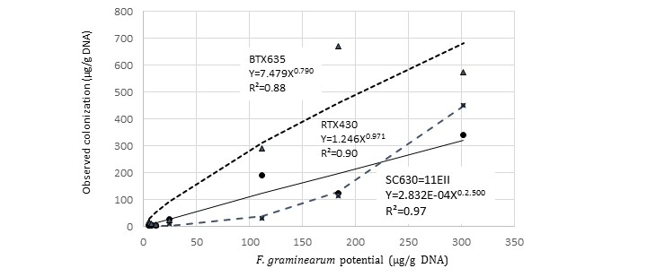

Figure 1 Relationships between F. graminearum species complex potential and observed colonization in 22 sorghum lines screened at Cedara and Alma over 6 seasons.

